SIMATS ENGINEERING (SAVEETHA SCHOOL OF ENGINEERING)
Department of Computer Science and Engineering
CO2 ASSESSMENT TOOL 2 – ARCHITECTURE DESIGN ASSIGNMENT
Software Architecture Design Report
Problem Statement 17
AI-Based Road Surface Damage Detection and Maintenance Planning System
Field | Details
Course Code | CSA10
Course Title | Software Engineering
CO Assessed | CO2 – Design scalable architectures & prioritise features
Assessment Tool | AT2 – Architecture Design Assignment
Weightage | 20% (Total Marks: 25)
Student Name | P SOMA SHANKAR REDDY
Register Number | 192465066
Date | 05/08/2026
Duration | 60 minutes
Code of Conduct
I (P SOMA SHANKAR REDDY / 192465066) certify that this submission is my original work and that I have adhered to the guidelines specified for this assessment. I understand that any violation of academic integrity rules will result in disciplinary action.

17. AI-Based Road Surface Damage Detection and Maintenance Planning System

Industry Context

Road infrastructure requires regular maintenance to ensure public safety and efficient transportation. Manual road inspections are labor-intensive, expensive, and often fail to identify defects promptly. Artificial Intelligence, Computer Vision, Drone Imaging, and Geographic Information Systems (GIS) enable automated road condition assessment and predictive maintenance planning.

Problem Statement

Roads frequently develop cracks, potholes, and surface deterioration due to traffic load and environmental conditions. Conventional inspection methods rely on manual surveys, which are time-consuming and prone to human error. There is a need for an AI-based system capable of automatically detecting road damage from images captured by cameras or drones. The platform should classify road defects, estimate severity, prioritize maintenance activities, and generate GIS-based maintenance schedules. Such a solution will improve road safety while reducing maintenance costs.

Objectives

1. Detect road surface defects using AI.
2. Classify potholes and pavement cracks.
3. Estimate damage severity.
4. Generate GIS-based maintenance maps.
5. Prioritize repair activities.
6. Monitor road condition over time.
7. Produce infrastructure health reports.
8. Reduce inspection costs.

Expected Outcomes

1. Accurate road damage detection.
2. Faster maintenance planning.
3. Improved road safety.
4. Reduced infrastructure maintenance costs.
5. Efficient resource allocation.
6. Enhanced transportation quality.
7. Continuous infrastructure monitoring.
8. Increased public satisfaction.

1. Introduction
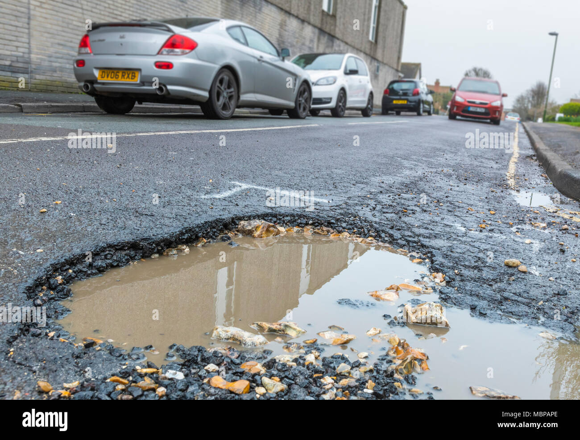
Road infrastructure requires continuous maintenance to ensure public safety and smooth transportation, yet conventional inspection relies on manual surveys that are slow, costly and error-prone. This report presents an architecture design analysis for an AI-Based Road Surface Damage Detection and Maintenance Planning System that automatically detects potholes and pavement cracks from drone/camera imagery, estimates defect severity, plots defects on a Geographic Information System (GIS), and generates prioritised, cost-efficient maintenance schedules. The objective of this document is to analyse the system requirements, select and justify a suitable software architecture, present the architecture diagram, describe component interactions, evaluate key quality attributes, and justify the architectural decisions taken.

Figure 0: Example of pavement distress motivating this system (insert your own image)

1.1 System Objectives
- Automatically detect road surface defects from images/video using AI.
- Classify defects such as potholes and pavement cracks.
- Estimate the severity of each detected defect.
- Generate GIS-based maintenance maps and road-condition heat maps.
- Prioritise repair activities based on severity, traffic and budget.
- Continuously monitor road condition over time.
- Produce infrastructure health reports and reduce manual inspection costs.

2. Analysis of System Requirements
The problem statement was analysed to extract the functional capabilities the system must deliver and the non-functional (quality) constraints that shape the architecture. These requirements directly informed the choice of architectural style described in Section 3.

2.1 Functional Requirements
ID | Functional Requirement
FR-1 | Capture road images/video via drone flights and vehicle-mounted cameras.
FR-2 | Ingest, pre-process and store images with GPS metadata for every survey run.
FR-3 | Detect and classify surface defects (potholes, cracks, ravelling, rutting) using a computer-vision model.
FR-4 | Estimate severity of each defect (low / medium / high) from size, depth and defect type.
FR-5 | Geo-tag every detected defect and plot it on a GIS-based road condition map.
FR-6 | Prioritise repairs and auto-generate maintenance schedules based on severity, traffic volume and budget.
FR-7 | Allow field engineers to view, verify, and update defect records from a web or mobile dashboard.
FR-8 | Generate periodic infrastructure health and cost-saving reports for municipal authorities.
FR-9 | Send automated alerts/notifications for high-severity defects requiring urgent action.
FR-10 | Track the condition of the same road segment over time to monitor deterioration trends.

2.2 Non-Functional Requirements & Quality Attributes
Beyond functionality, the following quality attributes most strongly influence the architecture, since the system must handle large-scale, geographically distributed image data with near-real-time detection and dependable scheduling output.
Attribute | Requirement
Scalability | Must process image batches from hundreds of drones/vehicles across multiple cities concurrently.
Performance | Defect detection inference should complete within a few seconds per image for near-real-time triage.
Reliability | Detection and scheduling pipeline must tolerate node/service failure without data loss.
Availability | Dashboard and reporting services should remain available 24x7 with minimal planned downtime.
Security | Role-based access control, encrypted data transfer, and secure storage of GIS and citizen-facing data.
Maintainability | Independent modules so the AI model, GIS engine, or scheduler can be updated without full redeployment.
Usability | Simple dashboards for non-technical municipal staff and field engineers.
Interoperability | Integration with third-party GIS/maps APIs and existing municipal maintenance-management systems.

3. Selected Software Architecture

3.1 Chosen Architectural Style
A hybrid architecture combining Microservices Architecture with an Event-Driven backbone (using a publish/subscribe message broker) is selected for this system. Each major capability – image ingestion, AI-based detection, severity estimation, GIS mapping, scheduling, reporting and notification – is implemented as an independently deployable microservice, and these services communicate asynchronously through events rather than tightly coupled synchronous calls.

3.2 Justification
- Image processing (drone/vehicle feeds) is bursty and compute-intensive; microservices allow the AI Detection service to be scaled independently (e.g., with GPU instances) without scaling the entire system.
- An event-driven backbone decouples the fast-moving detection pipeline from slower downstream processes such as scheduling and municipal-system integration, so a delay in one service does not block others.
- Each defect-processing stage (detection → severity → GIS → prioritisation → reporting) maps naturally to an independent service with a single responsibility, which is consistent with the functional decomposition identified in Section 2.1.
- Independently deployable services allow the AI model to be retrained/redeployed frequently without redeploying the GIS or scheduling modules, directly supporting maintainability.
- A pure layered or monolithic style was considered but rejected: it would tightly couple the AI inference workload with the request-handling layer, making it difficult to scale the compute-heavy detection stage independently and to update the model without a full-system redeployment.

4. Software Architecture Diagram
The diagram below shows the overall system structure across the client/edge layer, the API gateway, the microservices layer connected through an event/message broker, the persistent data layer, and integration with external GIS and municipal systems. Solid arrows indicate primary request/event flow; dashed arrows indicate integration or asynchronous response paths.
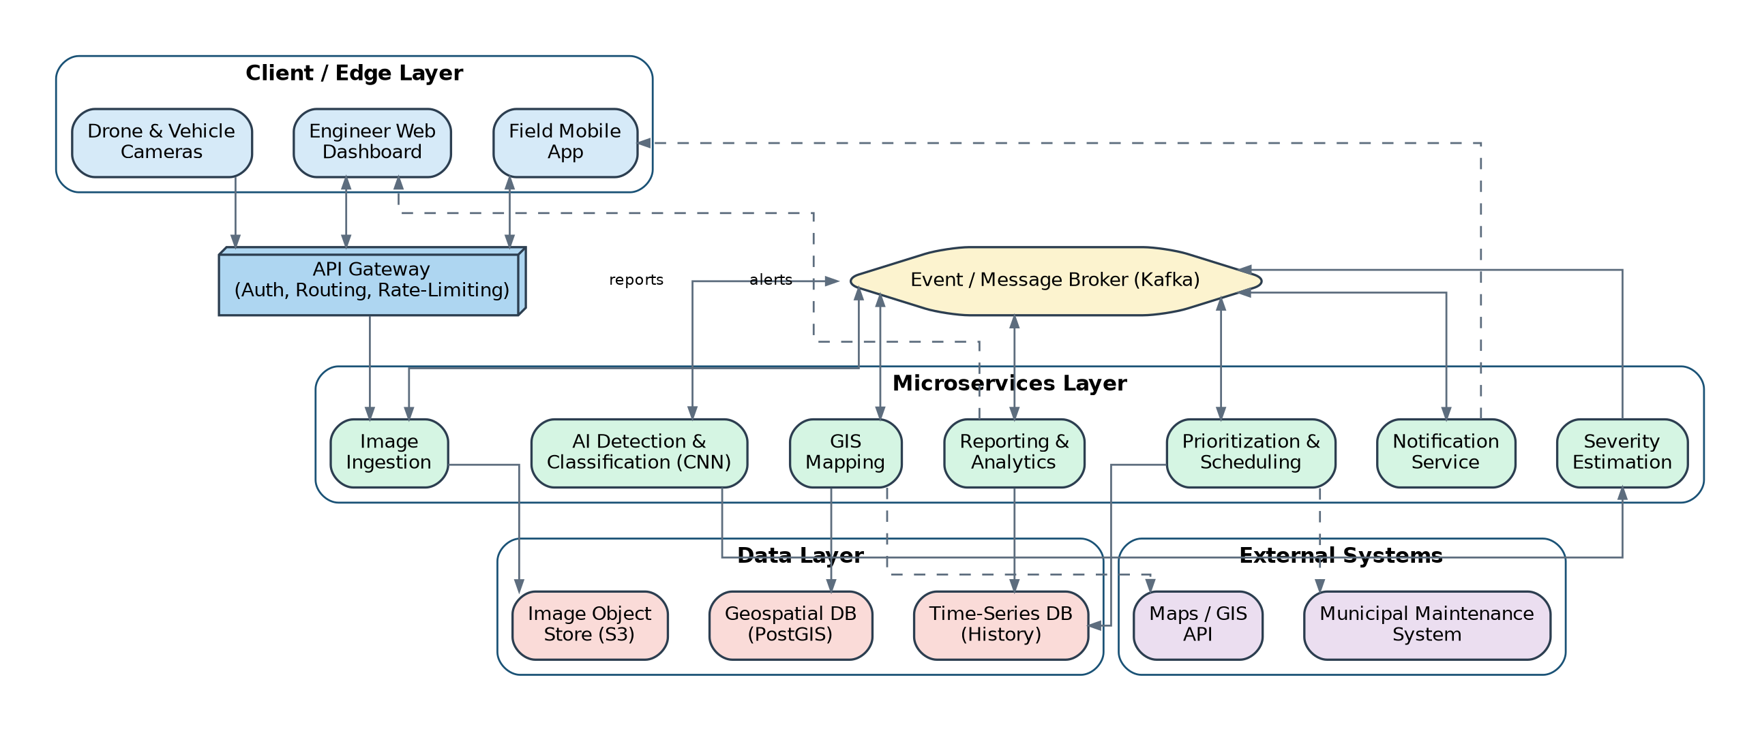
Figure 1: Hybrid Microservices + Event-Driven Architecture for the Road Damage Detection & Maintenance Planning System

5. Components and Their Interactions

5.1 Component Responsibilities
Component | Responsibility
API Gateway | Single entry point; handles authentication, request routing, rate-limiting and load balancing across services.
Image Ingestion Service | Receives raw images/video from drones and vehicle cameras, validates and stores them, and publishes an 'image-received' event.
AI Detection & Classification Service | Runs the CNN-based computer-vision model to detect and classify potholes, cracks and other pavement defects.
Severity Estimation Service | Analyses detected defects (area, depth, growth pattern) to assign a severity score.
GIS Mapping Service | Geo-tags each defect, updates the spatial database, and renders road-condition heat maps.
Prioritisation & Scheduling Service | Ranks defects by severity, traffic exposure and budget, and generates maintenance work orders.
Reporting & Analytics Service | Aggregates data into infrastructure health reports, cost dashboards and historical trend charts.
Notification Service | Pushes real-time alerts to field engineers and municipal staff for urgent defects.
Event / Message Broker (Kafka) | Decouples services; carries asynchronous events (image received, defect detected, severity scored, schedule updated) between microservices.
Data Layer (S3, PostGIS, Time-series DB) | Persists raw images, geospatial records and historical condition data respectively.
External Systems | Third-party Maps/GIS APIs and the municipal maintenance-management system that consumes generated work orders.

5.2 System Workflow
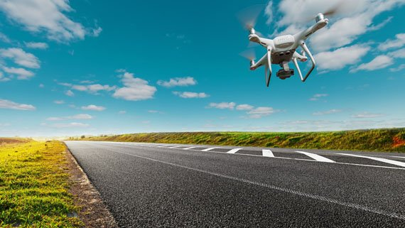
Figure 1a: Drone/vehicle-based image capture in the field (insert your own image)
The end-to-end workflow, from image capture to maintenance-report delivery, proceeds through seven stages as shown below. Each stage completes its task and publishes an event that triggers the next stage, allowing stages to run asynchronously and be scaled independently.
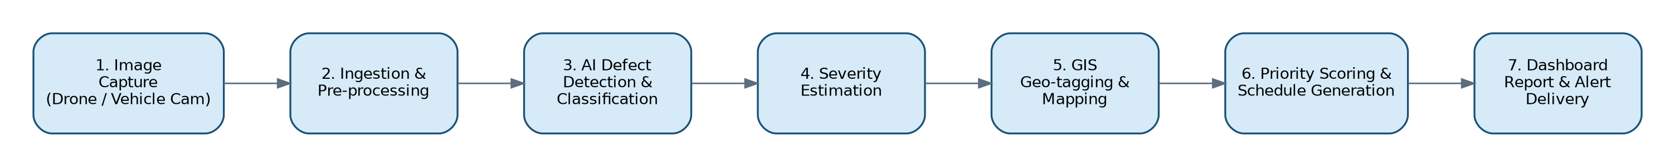
Figure 2: End-to-End System Workflow
- Drones and vehicle-mounted cameras capture road-surface images/video during scheduled or on-demand surveys.
- The Image Ingestion Service validates and stores each image with GPS/time metadata, then publishes an 'image-received' event to the broker.
- The AI Detection & Classification Service consumes the event, runs the CNN model, and publishes detected defects with type labels.
- The Severity Estimation Service scores each defect's severity and republishes the enriched record.
- The GIS Mapping Service geo-tags the defect and updates the spatial database and condition map, also syncing with the external Maps/GIS API.
- The Prioritisation & Scheduling Service ranks defects and generates work orders, optionally pushing them to the Municipal Maintenance System.
- The Reporting & Analytics Service and Notification Service consume the same event stream to update dashboards and alert field engineers of urgent defects.

6. Discussion of Quality Attributes
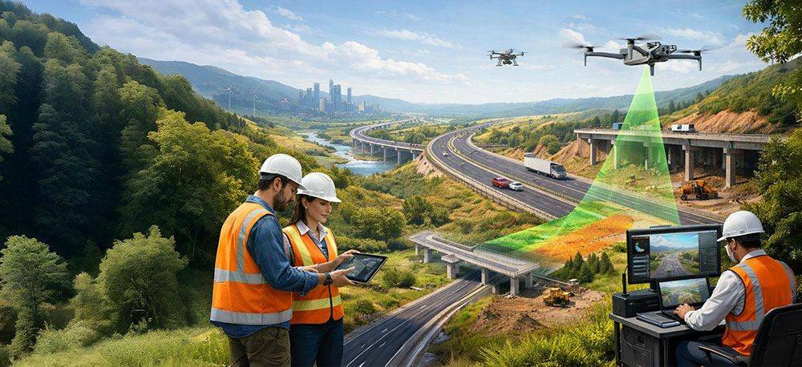
Figure 3: Sample GIS-based road-condition dashboard (insert your own image)

6.1 Scalability
Because each capability is a separate microservice, the compute-heavy AI Detection service can be horizontally scaled (additional GPU-backed instances) independently of lightweight services such as Notification, in direct response to survey volume across cities.

6.2 Security
The API Gateway centralises authentication and authorisation, enforcing role-based access so that only authorised municipal staff can view sensitive GIS or citizen-facing data; data in transit between services and to external systems is encrypted, and the message broker restricts topic access per service.

6.3 Performance
Asynchronous, event-driven processing prevents a slow downstream step (e.g., scheduling) from delaying image ingestion or detection, keeping the AI inference pipeline responsive for near-real-time defect triage even under bursty drone-survey loads.

6.4 Reliability
The message broker persists events and supports retry/redelivery, so a temporary failure in one microservice (e.g., GIS Mapping) does not cause data loss; failed events can be reprocessed once the service recovers.

6.5 Maintainability
Loose coupling between services means the AI model, GIS engine, or scheduling algorithm can each be updated, tested and redeployed independently, reducing regression risk and enabling faster iteration cycles for the detection model.

6.6 Availability
Redundant, independently deployed service instances behind the API Gateway, combined with the broker's buffering behaviour, allow the platform to keep accepting new images and serving dashboards even if a single downstream service is temporarily unavailable.

7. Justification of Architectural Decisions and Trade-offs
The hybrid microservices/event-driven style was chosen primarily to decouple the compute-intensive, bursty AI detection workload from the rest of the pipeline, and to allow independent scaling and deployment of each capability identified in the functional requirements.

7.1 Trade-offs Considered
- Operational complexity: running and monitoring several independent services and a message broker is more complex than a monolith, but this is offset by containerisation and centralized logging/monitoring.
- Eventual consistency: GIS maps and dashboards may lag slightly behind the latest detection event; this is acceptable since maintenance planning is not a hard real-time process.
- A pure Service-Oriented Architecture (SOA) with an enterprise service bus was also considered but rejected as heavier and less suited to the fine-grained, independently scalable services required here.

7.2 Support for Future Enhancements
- New defect types or a new AI model version can be introduced as an updated Detection service without touching other services.
- Additional data sources (e.g., IoT road-sensors, citizen-reported defects) can be added as new event producers to the same broker.
- The architecture supports integration with additional municipal or state-level GIS platforms as new external system connectors.
- Because services are independently deployable, the system can scale from a single city pilot to a state-wide rollout without a redesign.

8. Conclusion
The proposed hybrid Microservices and Event-Driven Architecture directly addresses the functional requirements (automated detection, severity estimation, GIS mapping and maintenance scheduling) and the non-functional requirements (scalability, performance, reliability, security, maintainability and availability) identified for the AI-Based Road Surface Damage Detection and Maintenance Planning System. By decoupling the compute-intensive AI pipeline from downstream GIS, scheduling and reporting functions through an event-driven backbone, the architecture is well positioned to scale across cities, evolve its AI models independently, and support long-term integration with municipal maintenance systems.

